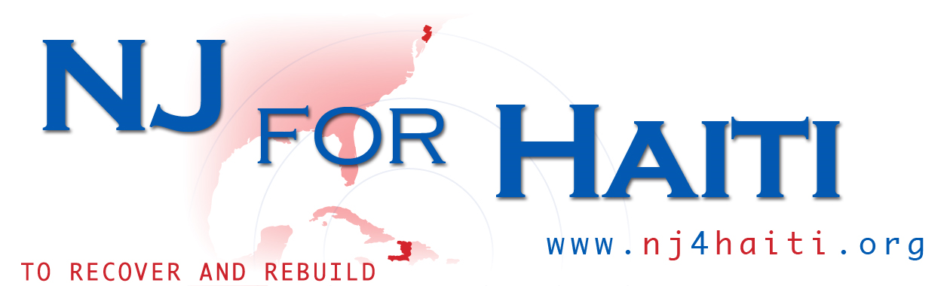

Haiti Mission Trip

Pisto, Haiti

August 12 - 19, 2018

Registration Forms & Checklist

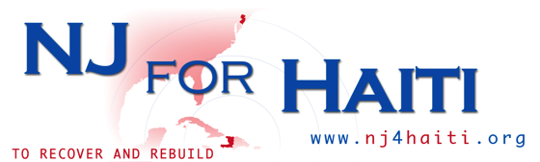

2018 HAITI MISSION TRIP
Sunday, August 12, 2018 through Sunday, August 19, 2018

NJ4Haiti is pleased to announce its Haiti Mission trip to Pisto, Haiti - which was extremely effected by the January 12, 2010 Earthquake. The dates are from Sunday, August 12– Sunday August 19, 2018. The purpose of the trip is to visit communities where people continue to need medical and counseling assistance.

This volunteer opportunity is geared towards individuals who desire to give their time to make a lasting impact and to partner with an organization that is dedicated to transforming Haiti in the short and long term.

This is a very unique opportunity for individuals to directly provide aid in the relief efforts. We believe that the best way to raise awareness and make a direct and lasting impact is to have individuals become intimately involved in changing Haiti for the better. Those who participate in this program will gain a keen understanding of the devastation experienced by the Haitians, the resilient spirit of the Haitian population to continue to have hope for their future and the proactive steps that concerned citizen can take to rebuild Haiti for the next generation.

NJ4Haiti is led by dedicated staff members who have roots in the Haitian community – they have lived in Haiti and/or visited Haiti many times. We work closely with Haitians and friends of Haiti, in America and internationally. Our staff members are fluent in Haitian Creole and understand Haitian culture.

Highlights:

- Live and Work alongside local people and other volunteers
- Learn about Haiti and the challenges it faces
- Work with NGOs and gain relief volunteer experience
- Help the people of Haiti who desperately need it
- Learn to speak basic Haitian Creole and to understand Haitian culture
- Obtain a life changing experience that will be memorable

Skills & Qualifications:

Seeking medical professionals, educators, psychologists, counselors, pharmacists or concerned citizens who are willing to assist in medical facilities as needed.

- Must be willing to experience new things
- Must be a team player with an open mind
- Must be 18 years of age or older
- Additional Trip Details
- Destination: Pisto, Haiti
- Hotel Accommodations:

Group size: Limited to 25 people

Volunteer work: Visit schools, and orphanages. The team will provide medical assistance, feed meals to the community, as well as participate in a community based project.

- Estimated Trip Cost: $1800 (covers the expenses below)
- Accommodations: Lodging and meals provided
- Meals: Haitian cuisine prepared fresh daily (breakfast and dinner). Daily supply of bottled water.
- Transportation will be provided between airport and lodging site, as well as between volunteer sites
- Language and Culture Training prior to trip (USA)
- Orientation prior to the trip
- Medical/ School supplies for the community

Flight:
We will be using JetBlue Airlines. Please reserve flight 634 leaving from JFK at 9:48 am on Sunday 08/12/18 going to PAP and flight 1834 leaving from PAP at 3:02 pm on Sunday 08/19/18 to JFK.

REGISTRATION INSTRUCTIONS

1. Complete registration form and send via email to nj4haiti@gmail.com

Our offices will review your registration form and contact you via email with a confirmation of your participation in this trip.

Once your participation is confirmed, purchase your airfare immediately (refer to page 4)

2. View and follow the payment schedules below to secure your participation in the trip.

Payment Schedules

March 1st: $360

April 1st: $360

May 1st: $360

June 1st: $360

July 1st: $360

Final Payment:

Final payments are due no later than July 1st, 2018 to confirm your room and board.

(Mail all payment via check or money order made payable to NJ4Haiti c/o United Way of Greater Union County)

****************************Final Payment deadline is July 1st, 2018****************************

Mail payment for trip cost along with completed and signed forms (see list below).

Once again, our offices must receive payment and forms by mail, no later than July 1st, 2018 to finalize your registration.

- Mail payments via check or money order. Checks should be made payable to “NJ for Haiti”
- Completed Permissions and Liability Release
- Completed Code of Conduct Form
- Completed Emergency Medical Information Form
- Color copy of your passport
- Copy of medical insurance card
- Copy of airline ticket receipt

3. A final confirmation will be sent via email about your completed registration.

Please email this form to nj4haiti@gmail.com

Return the original version by mail to:

NJ for Haiti
c/o United Way of Greater Union County
33 West Grand Street
Elizabeth, New Jersey 07208
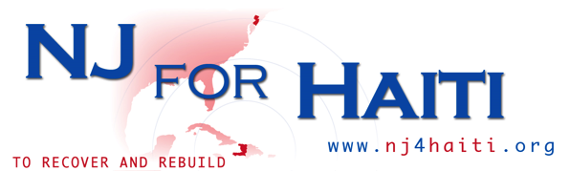

REGISTRATION FORM

Haiti Mission Trip

Trip Destination: Pisto, Haiti Trip Dates: August 12 -19, 2018

Last Name |  | First Name |  |  | M.I. | Date
Street Address |  |  |  |  | Apartment
City |  | State |  |  | Zip
Phone | ( ) | E-mail Address
Citizen of: |  | Birth Date |  |  | Age
Gender |  | Marital Status
Occupation |  | Description

Have you had previous experience in the mission field or traveled in a foreign country?

If yes, please explain:

Emergency Contacts in the U.S.
Name |  | Name
Phone | ( ) | Phone | ( )

What foreign language do you speak?

List any medical or first aid training:

What area do you feel you can contribute the most in during the trip?

- Medical
- Recreations
- Cooking/Meal Prep
- Educational Workshops

You will need a Passport
Passport Number: |  | Expiration Date:

Please send a copy of the front page of your passport (photo and passport number).

Please email this form to nj4haiti@gmail.com

Return the original version by mail to:

NJ for Haiti
c/o United Way of Greater Union County
33 West Grand Street
Elizabeth, NJ 07202
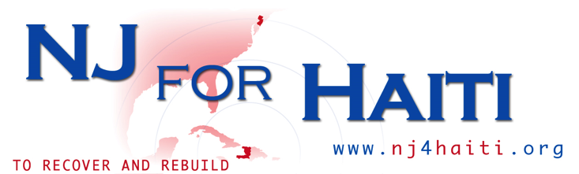

PERMISSIONS AND LIABILITY RELEASE
Haiti Mission Trip

Trip Destination: Pisto, Haiti Trip Dates: August 12 - 19, 2018
I understand that the Haiti mission trip for which this Permissions and Liability Release Form is being given is described as follows:

A mission trip is being coordinated by the non-profit organization, NJ4Haiti, for adults to travel to Pisto, Haiti, on Sunday, August 12th- Sunday, August 19th, 2018. This mission trip may include work at tent cities, orphanages, schools and churches.

I hereby consent to my participation in the above-described event. I understand that my participation in this event presents varying degrees of risks—some of which are unknown—which may arise from a condition of the premises at which the various event activities are held and/or the areas we will pass through on our travels; from an action of any person in connection with the conduct of any planned or unplanned activity; or from other unforeseen elements. I acknowledge that such known and unknown risks exist, I understand that I may incur personal injury or property damage while participating in this event, and I fully and willingly agree to assume all risks associated with this event.

I consent to first aid and emergency medical care for myself by any mission team member (and/or any other adult appointed or designated by him/her) and authorize, if necessary, admission to a hospital or health care or diagnostic facility, and/ or medical evacuation, for treatment of injuries that are sustained while participating in this event.

I give permission for any mission team member (and/or any other adult appointed or designated by him/her) to provide transportation or arrange for transportation, if needed, for medical care.

I understand that I am responsible for any and all medical expenses that I may incur, including medical transport, as a result of any accident or illness while participating in this event. I understand that I have a duty to provide, and that I am covered, by primary accident and medical insurance.

I release and forever discharge NJ4Haiti, their agents and volunteer servants, successors and assigns, directors, trustees, officers, employees, and other representatives from any and all damages and causes of action either at law or in equity that I may have as a result of my participation in, attendance at, and travel to and from the event. Furthermore, I do hereby expressly stipulate, and agree to indemnify and hold forever harmless NJ4Haiti, their agents and volunteer servants, successors and assigns, directors, trustees, officers, employees, and other representatives against loss from any and all present or future claims, demands, or actions in law or in equity that may hereafter be made or brought by me, by anyone on my behalf, or by anyone else on their behalf for damages or any other legal or equitable remedy on account of any injury, illness, physical condition, inconvenience or loss sustained by me/my child during the event or travel to and from the same.

I, ____________________hereby acknowledge that I have read the foregoing, understand its content, and have signed the same as my own free act and deed.

Participant: (please print): ___________________________

________________________ ____________ _________________________
Participant Signature Date Witness

Code of Conduct
Haiti Mission Trip

Trip Destination: Pisto, Haiti Trip Dates: August 12 - 19, 2018

I accept the Code of Conduct guidelines listed below for participating in this trip. I go not as a tourist, but as a guest of another country. I understand that Haiti is not considered a Developed Country and does not have the same conveniences I may be accustomed to at home.

I recognize and accept the following conditions which will further the usefulness and safety of our short-term mission. If accepted as a member of this NJ4Haiti team, I agree to:

- Adopt an attitude that I am on this team to try to understand the host culture, not to convince them of my own viewpoint or style. I understand that there are many different ways to accomplish the same objective and know that my way is not necessarily the best.
- Abstain from making derogatory comments to team members or about our host country regarding people, politics, sports, religion, race, or traditions.
- Accept and submit to the leadership role and authority of the trip director and promise to abide by his or her decisions as they concern this mission trip.
- Understand that our team’s work is but a tiny speck on the bigger picture that our mission partners are trying to accomplish. I promise not to be overly demanding, to do my best not to offend or cause embarrassment for the local mission host and to help them attain their long-term goals.
- Attend all team meetings possible, both prior to departure (if any are scheduled) and during the mission trip.
- Expeditiously follow up on all requirements for passports, visas, financial obligations, vaccinations, travel insurance, etc.
- Refrain from meddling, complaining, and obscene or insensitive humor or behavior.
- I understand that I must travel with the rest of the team, unless other prior arrangements are made and the trip director has been notified in advance of the trip.
- If a loved one or dear friend is traveling with me, we agree to interact with all members of the team, not just one another.
- Avoid any actions that might be perceived as amorous attentions toward any people I meet while on the mission trip.
- Refrain from giving gifts, such as money, clothes, jewelry, CD players, etc. to the locals. Although the intent of the giver is good, the result after we leave causes problems for our host, and jealously and bitterness among those locals who received no such gifts. If I feel compelled to give a gift to someone I have met, I will consult first with the trip director before I promise or give the gift, and I promise to let him or her make the final decision on this matter.
- I will respect the advice I am given concerning attire, eating and drinking, and other such traditions that will help me to assimilate into the local community.
- I agree that in the event my conduct is considered so unsatisfactory that it jeopardizes the success of the trip, and that mediation during the trip has failed to correct my behavior, that my services in connection with this mission shall end and I shall return home immediately at my own expense.
- In signing below, I represent that I am 18 years of age or older, or my parent/guardian will sign also, accepting the above conditions on my behalf.

Participant: (please print):_______________________

____________________________________ ____________
Participant Signature Date
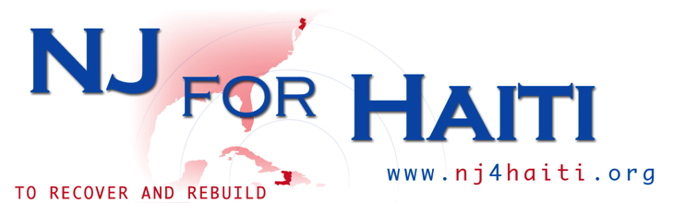
EMERGENCY MEDICAL INFORMATION FORM
Haiti Mission Trip

Please complete so that health care providers can be aware of your personal health needs. This form must be completed and carried by all event participants.

Name of participant:

Does the participant have: (if “yes”, please explain)
Yes No ALLERGIES:
Yes No HEART CONDITION:
Yes No ASTHMA:
Yes No OTHER:

Is the participant subject to: (if “yes”, explain)
Yes No HEADACHES:
Yes No SEIZURES:
Yes No MOTION SICKNESS:
Yes No FAINTING:
Yes No SLEEP WALKING:
Yes No UPSET STOMACH:
Yes No OTHER:

Does the participant have a reaction to: (if “yes”, explain).
Yes No BEE STINGS:
Yes No PENICILLIN:
Yes No OTHER DRUGS:
Yes No POISON IVY, OAK, SUMAC:
Yes No OTHER:

Yes No Has the participant had any serious illness or surgery within the past 10 years? Please list:
Yes No Does the participant have any condition that would prevent him/her from participating in any activities? Please list:
Yes No Does the participant take any prescription medication? Please list, including dose and times:
Yes No Are any drugs ineffective in treatment?
Yes No Is the participant diabetic? Medication?
Yes No Does the participant have any sight or hearing impairment?
Yes No Does the participant wear contact lenses?
Yes No Does the participant wear hearing aids?

Date of last tetanus shot: ___ / ___ / _____

A current tetanus shot is required. After seven (7) years, another tetanus shot is recommended.

Please indicate ANYTHING else that leaders should know to help avoid or deal with any medical situation that might arise:

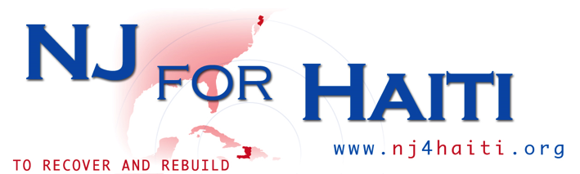

Preparations for Haiti Mission Trip

- Get a passport. Applications are at the Post Office. You will need to have 2 copies of a picture of yourself taken. The passport process can take 6-8 weeks. To apply or renew your passport, go to http://travel.state.gov/passport/passport_1738.html. Costs vary.

- Immunizations are necessary.

Visit the Center for Disease Control’s website to find out the latest on immunizations necessary prior to going to Haiti: http://wwwnc.cdc.gov/travel/destinations/haiti.htm

- Check with your health care provider regarding whether you have had any of these immunizations already and if not, what is covered by your insurance. If your provider does not cover these immunizations, you can contact your county Health Department. Costs will vary.

- The recommended shot/vaccines as of May 2012 are as follows (however the CDC or your health professional may recommend differently).

- Typhoid – shot is good for 2 years, oral vaccine is good for 5 years
- Hepatitis A series
- Hepatitis B series
- Rabies
- Meningitis
- Diphtheria/Pertussis/Tetanus (DPT)
- Dengue
- Flu
- Malaria preventative (series of weekly pills)

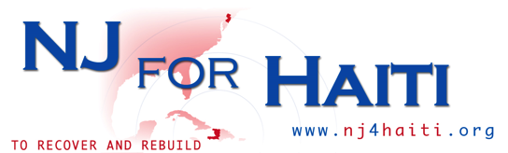

Important Items to Bring While in the Field

- Money Belt
- Lock for your suitcase
- Personal medications, including malaria pills and motion sickness meds
- Bug repellant with Deet
- Water bottles / Bottled Water
- Sunglasses
- Sun Block (STRONG, not less than 30 SPF)
- Hat (for the sun)
- Camera w/ extra batteries
- First aid kit
- Bandanas (very handy)
- Antibacterial hand lotion

- Comfortable walking shoes
- Flip flops for the shower
- Roll of toilet paper
- Backpack to carry items around (water, supplies, snacks etc.)
- Earplugs
- Snacks
- Wet Ones (wipes)
- Wash Cloths

- Anti-Diarrhea pills

